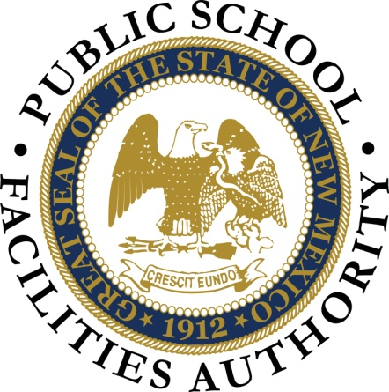
The Ben Lujan Maintenance Achievement Awards, in its 16th year, were created to recognize NM Public School maintenance and operations staff and teams dedicated to maintaining quality facility conditions supporting their educational environments and the success of teachers, students and communities. The awards, named in honor of the late Speaker of the House, Ben R. Lujan, continue his passion for the students of our state in acknowledging the hard work our maintenance/custodial staffs perform on a daily basis to provide for educational facilities that are outstanding in form and function.
Several New Mexico Schools Districts were recognized with performance awards at the 2022(FY23) Ben Lujan Maintenance Achievement Awards ceremony presented in Albuquerque during the CES Facility Managers Training Workshop at a luncheon ceremony on Monday October 17, 2022. Keynote speaker, David L. Robbins, Public Education Commission, representing the PSCOC/AMS and PSFA Director, Martica Casias presented the awards. The 2022 Plant Manager of the Year award was also presented.
Highest Achievement District Performance Awards - Awarded to NM School districts who demonstrate continuous and sustained performance. Based on district application and the FMAR Performance ratings.
Gadsden Independent School District Hobbs Municipal School District
Central Consolidated School District

Individual and Team Awards - nominated by their district Board, Superintendent and/or Facility Manager. 31 Individual Awards and 3 District Team Awards were presented. NM Districts staff honored in this category included:
West Las Vegas City School District
Los Alamos Public Schools
Gadsden Independent School District
Las Cruces Public School District
Central Consolidated School District
Floyd Municipal School District
House Municipal School District
Tucumcari Public Schools
Rio Rancho Public School District

A list of individual award winners will be made available as soon as districts have the opportunity to present individual awards at their district board meetings.

District Team Awards
Los Alamos Public School District Rio Rancho Public School District Central Consolidated School District

Plant Manager of the Year Award 2022: Individual Facility Manager, nominated by district superintendent and/or district leadership: Cody Ryen, Tucumcari Public School District

